Quiz 02
- Consider the following bridge full wave rectifier
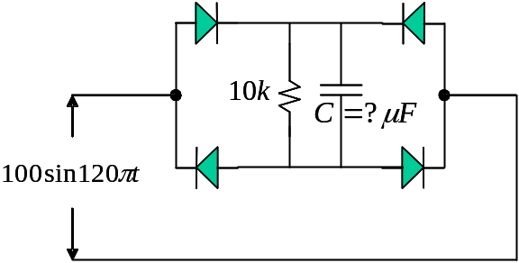

Determiner 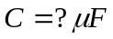 such that the DC ripple 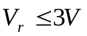

- Consider the following limiter circuit and assume all diodes are ideal
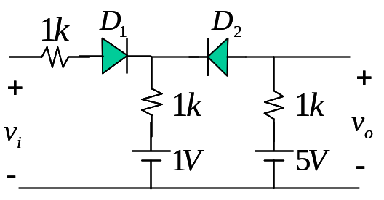

Find the input-output transfer curve.

- Consider the following limiter circuit and assume all diodes are ideal
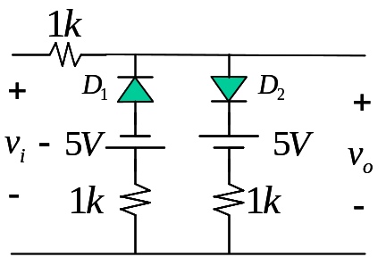

Find the input-output transfer curve.

- Consider the following Zener diode circuit
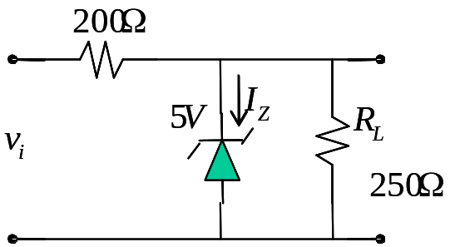

Let 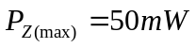 and 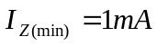, find the range of 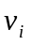 such that 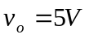.

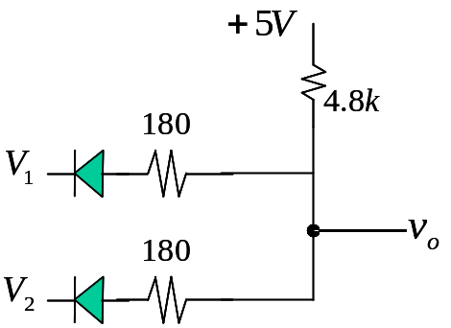
- For the following circuit, the diode has 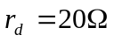, 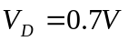. Find 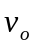 for the case of 